

California Workers’ Compensation Institute

1333 Broadway - Suite 510, Oakland, CA 94612 • Tel: (510) 251-9470 • Fax: (510) 763-1592

May 18, 2018

VIA E-MAIL – [DWCForums@dir.ca.gov](mailto:DWCForums@dir.ca.gov)

Maureen Gray, Regulations Coordinator

Division of Workers’ Compensation, Legal Unit

P.O. Box 420603

San Francisco, CA 94142

**Re: Forum Comment: Medical-Legal Fee Schedule Regulations**

Dear Ms. Gray:

On behalf of its members, California Workers’ Compensation Institute offers these comments on the proposed amendments to the Medical-Legal Fee Schedule regulations. The Institute members include insurers writing 83% of California’s workers’ compensation premium, and self-insured employers with $65B of annual payroll (30% of the state’s total annual self-insured payroll).

Insurer members of the Institute include AIG, Alaska National Insurance Company, Allianz Global Corporate and Specialty, AmTrust North America, Berkshire Hathaway, CHUBB, CNA, CompWest Insurance Company, Crum & Forster, EMPLOYERS, Everest National Insurance Company, The Hartford, ICW Group, Liberty Mutual Insurance, Pacific Compensation Insurance Company, Preferred Employers Insurance, Republic Indemnity Company of America, Sentry Insurance, State Compensation Insurance Fund, State Farm Insurance Companies, Travelers, XL America, Zenith Insurance Company, and Zurich North America.

Self-insured employer members include Adventist Health, Albertsons/Safeway, BETA Healthcare Group, California Joint Powers Insurance Authority, California State University Risk Management Authority, Chevron Corporation, City and County of San Francisco, City of Los Angeles, City of Torrance, Contra Costa County Risk Management, Contra Costa County Schools Insurance Group, Costco Wholesale, County of Alameda, County of Los Angeles, County of San Bernardino Risk Management, County of Santa Clara Risk Management, Dignity Health, Foster Farms, Grimmway Farms, Kaiser Permanente, Marriott International, Inc., North Bay Schools Insurance Authority, Pacific Gas & Electric Company, Schools Insurance Authority, Sempra Energy, Shasta County Risk Management, Shasta-Trinity Schools Insurance Group, Southern California Edison, Special District Risk Management Authority, Sutter Health, University of California, and The Walt Disney Company.

Recommended revisions to the proposed regulation are indicated by underscore and ~~strikeout~~. Comments and discussion by the Institute are identified by *italicized text*.

The Institute congratulates the Division on drafting regulatory changes to address interpretation issues related to complexity factors used to determine billing and payment levels for medical-legal services. The Institute provides the following recommendations for additional clarity.

**Recommendation:**

**§ 9794. Reimbursement of Medical-Legal Expenses.**

(a)(3) No other charges shall be billed under the Official Medical Fee Schedule in connection with a medical-legal evaluation or report; and neither the employee nor the employer shall be liable for any charges billed in violation of this section.

**Discussion:**

*The additional language would help avoid unintended disputes.*

**Recommendation:**

(g) If the claims administrator receives a written objection to the denial of the medical-legal expense under subdivision ~~(d)(~~f) within ninety (90) days of the service of the explanation of review, the claims administrator shall file a ~~petition to review of the denial of medical-legal expense~~ “Petition for Determination of Non-IBR Medical-Legal Dispute” and a declaration of readiness to proceed pursuant to section ~~10228~~ 10205.10 et. seq.

**Discussion:**

*Referencing subsection (f) corrects an error that appears to have been introduced when the regulations were filed with OAL. Below is the text from the 2nd comment period.*

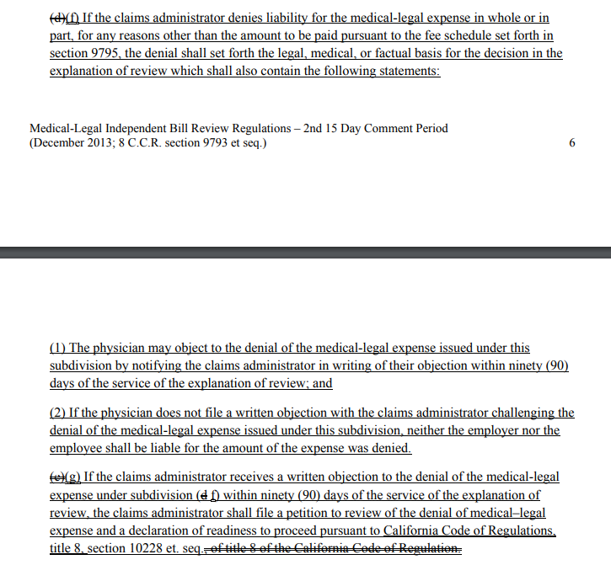

*Naming the document identified under §10451.1(2)(A) is appropriate. This may also be an appropriate time to correct the previously renumbered section (10228 to 10205.10).*

**Recommendation:**

**§ 9795. Reasonable Level of Fees for Medical-Legal Expenses, Follow-up, Supplemental and Comprehensive Medical-Legal Evaluations and Medical-Legal Testimony.**

(b) The fee for each evaluation is calculated by multiplying the relative value by $12.50, and adding any amount applicable because of the modifiers permitted under subdivision (d). The fee for each medical-legal evaluation procedure includes reimbursement for the history and physical examination, review of records, preparation of a medical-legal report, including typing and transcription services, and overhead expenses. The complexity of the evaluation is the dominant factor determining the appropriate level of service under this section; the times to perform procedures is expected to vary due to clinical circumstances, and is therefore not the controlling factor in determining the appropriate level of service. ~~If prior agreement of the parties is required under any provision of this regulation,~~. ~~the~~The physician may not condition performance of the evaluation, or issuance of the related report, on receipt of any prior agreement of the parties under this regulation.

(c)

|  |  |  |
| --- | --- | --- |
| ML103 | 75 | *Complex Comprehensive Medical-Legal Evaluation*. Includes evaluations which require three of the complexity factors set forth below. |
|  |  | In a separate section at the beginning of the report, the physician shall clearly and concisely specify which of the following complexity factors were actually and necessarily incurred for the production of the medical-legal report, ~~and were~~ why they were required for the evaluation, and the circumstances uniquely specific to the actual evaluation being performed ~~which~~ that made these complexity factors applicable ~~to the evaluation~~. |
|  |  | (1) Two or more hours of face-to-face time by the physician with the injured worker; |
|  |  | (2) Two or more hours of record review by the physician. An evaluator who specifies this complexity factor must provide in the body of the report a list and a summary of the medical records reviewed pursuant to Labor Code § 4628(a)(2), as well as the name and credentials for the individual who provided the record review and summary. ~~All criteria except the amount of hours must also be satisfied to use record review in combination under subdivision (4) and (5) of this code;~~ |
|  |  | (3) Two or more hours of medical research by the physician, using sources that have not been cited in any prior medical report authored by the physician in the preceding 12 months, in support of a claim citing or relying upon this complexity factor. An evaluator who specifies this complexity factor must also (A) explain in the body of the report why the research was reasonably necessary to reach a conclusion about a disputed medical issue, (B) provide a list of citations to the sources reviewed, and (C) excerpt or include copies of medical evidence relied upon. ~~All criteria except the amount of hours must also be satisfied to use medical research in combination under subdivision (4) and (5) of this code;~~ |

**Discussion:**

*§9795(b): Because no agreement is ever required, the focus of the language should remain on the physician’s duty to provide an evaluation and report pursuant to the regulations.*

*Corrections to syntax and text are suggested in §9795(c), ML103 – 75.*

*In §9795(c), ML103 – 75 (2), additional language mirroring the disclosure requirements under Labor Code §4628(b) is appropriate.*

*The Division’s intent in the closing sentences in both (2) and (3) of §9795(c), ML103 – 75, is not apparent. The language should be revised or deleted.*

Thank you for the opportunity to comment, and please contact us if additional information would be helpful.

Sincerely,

Stacy L. Jones

Senior Research Associate

SLJ/pm

cc: André Schoorl, DIR Acting Director

George Parisotto, DWC Administrative Director

CWCI Claims Committee

CWCI Medical Care Committee

CWCI Legal Committee

CWCI Regular Members

CWCI Associate Members